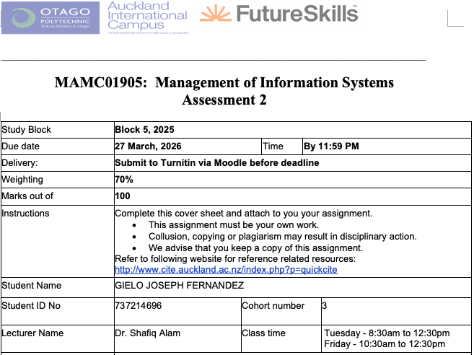
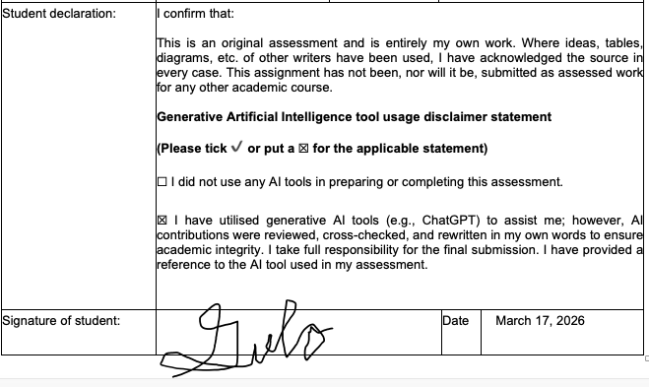
Transformation of Southern Cross Health AI Chatbot

Case Study
Southern Cross is a leading health insurance provider in New Zealand, offering services such as life, health, pet, and travel insurance (Southern Cross Healthcare). The company focuses on delivering accessible and reliable insurance solutions to its members.
Currently, Southern Cross uses Aimee, an AI chatbot that answers customer questions about the health system and insurance terms (McGregor, 2019). While helpful for general inquiries, Aimee’s capabilities are limited and do not provide personalized guidance.
In the future, Aimee could be enhanced to assist with claims, estimate coverage in real time, and offer tailored plan suggestions based on individual profiles and health history. This would transform her into a proactive digital assistant, improving the overall member experience.
To achieve this, Southern Cross will develop and train advanced AI models, integrate comprehensive data governance and security measures (MinterEllison New Zealand, 2025), and adopt Agile methods for continuous improvement..

1.Introduction
In today’s age, chatbots plays a huge part in the success of organizations, not just insurance organizations. Chatbots, also referred to as conversational agents, are interactive intelligent systems that utilize Natural Language Processing (NLP) and machine learning to conduct text or voice-based conversations with humans (Rodríguez Cardona et al., 2021).
In the insurance industry, chatbots are vital for driving digital transformation and helping traditional companies remain competitive against emerging Insurance tech startups (Subhashini et al., 2025). They provide critical 24/7 availability, allowing policyholders to receive immediate clarifications on policy features, premium payments, and claim procedures (Ezhilarasi, 2025).
Southern Cross, New Zealand’s leader in providing health insurance. Southern Cross currently has different cashflow or services such as life insurance, health insurance, pet insurance, and travel insurance(Southern Cross). For Southern Cross, the transformation of the ai chatbot will drive operational efficiency, enhance customer engagement, and provide a strategic competitive advantage in a market increasingly disrupted by Insurance Tech startups (Rodríguez Cardona et al., 2019).
This report will analyse the transformation of AI Chatbot for Southern Cross. Part two will discuss the evolution of AI Chatbot, and the present policies and management regarding the AI Chatbot in Southern Cross. Part three will discuss the current trends and future development of AI Chatbot. Part four will discuss the recommendations and will conclude with the summary in part five.

Part two will discuss how AIS is used by Southern Cross as well as the past, current, and future AIS for Southern Cross. And finally close with the summary and conclusion of part three.
In today’s age, accounting plays a huge part in the success of organizations, not just insurance organizations. Accounting can be defined as the scheme and art of collecting, classifying, summarizing, and communicating financial data to facilitate economic decision-making (Muzeyen, 2021). Accounting’s primary purpose is to identify and record economic events, supplying both internal and external users with the information needed to make reasoned choices regarding the allocation of scarce resources (Bakhshi, 2018).
In the insurance sector, Accounting function is uniquely critical due to the high degree of regulatory scrutiny, long-term nature of liabilities, and the necessity of maintaining trust with policyholders (Kuvatova Dinara, 2024).
Southern Cross, leader in providing health insurance to New Zealanders. Southern Cross has different cashflow or services such as life insurance, health insurance, pet insurance, and travel insurance (Southern Cross Healthcare). For Southern Cross, the Accounting Function serves as a strategic business resource that has evolved from routine support to a critical tool for competitive advantage and high-level management inquiries (Demianchuk et al., 2025).
This report will analyse the evolution of Accounting Information Systems(AIS) for Southern Cross. Part two will discuss how AIS is used by Southern Cross as well as the past, current, and future AIS for Southern Cross. And finally close with the summary and conclusion of part three.
Lorem ipsum
• The definition ( what is inflight entertainment system )
• The background of the system (how it has evolved and what is need for this )
• Motivation why is that function important ( why is having a good inflight system important to have for air NZ )
• Objectives
• Structure
2. Evolution of Chatbot System at Southern Cross Health
A number of changes have happened in how Southern Cross Healthcare has been manging the policies and the procedures related to their enterprise resource planning systems. Below, we talk about their current state of the art in terms of Managerial policies and procedures.
2.1 Present management policies and procedures ( 700 words)
The management procedures, as part of ERP security management, managers implement Role-Based Access Control (RBAC) by assigning users permissions strictly according to their job responsibilities, and enforce Multi-Factor Authentication (MFA) to ensure that all system access requires additional verification, thereby protecting sensitive data.

As the contemporary policies, the curent policies relate to the above two procedures are outlined here..
Example Access Control Policy (Retail Industry Style)
"All employees must be assigned access to the ERP system strictly according to their role. Access beyond the role must be requested through the formal approval workflow and is subject to quarterly review. User accounts are deactivated immediately upon termination or role change to prevent unauthorized access."
— Adapted from best practices outlined in SANS Institute ERP Security Guidance
Example Multi-Factor Authentication Policy (Retail Industry Style)
"All system users are required to authenticate using a password plus a secondary verification method such as a one-time passcode or hardware token. Accounts will be locked after five consecutive failed login attempts, and managers must review failed access attempts monthly to ensure compliance."
— Adapted from publicly available ERP security recommendations for retail and large organizations (ISACA, ERP Security Controls)

i. Management Procedures (how it works- what are the steps. Not steps of usage but of management- Think yourself to be the manager of the systems- don’t talk about how user use the systems… talk about how the systems is managed, how the systems are updated, how the systems are retired. the processes… … Need to talk about management activities rather than usage activities.)

ii. Management Policies (rules)- for example who (who decides what contents (movies) should be added. Who ads it, who updates the system.) what are the rules for security policies, privacy policies etc.

3. Current Trends and Future Developments
There are a number technology taht is up for adoption in term ERP in the domain of hardware, software, network, and data. Some of such technology is analysed below that well suit the needs of TWS.
3.1 Current Trends in information system

3.1 future developments in information system

3. 3 Transition TWS from current to goal state
Talk about the framwork of transition. ... TOGAF and zachman.
• - from mission and vision of TWG
• Their current state in one sentence from the prvious section and based on the Merly’s maturity model, since the TWG is level 2 mosly, it need to transition to level 3.
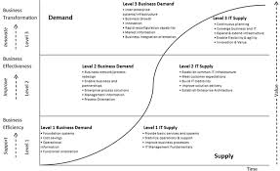

• Their goal state form the section above -> level 3. on the merlyns maturity model
• The framework of how to change / transition
Lorem ipsum
4. Recommendations
Lorem ipsum
5. Summary and Conclusion
Lorem ipsum
6. References
Ezhilarasi, A. (2025). AI chatbot interactions and customer satisfaction in the insurance sector: Evidence from Star Health & Allied Insurance Company Limited in Chennai.
McGregor, A. (2019, November 21). Human touch meets AI on health insurance frontline. Southern Cross NZ. https://www.southerncross.co.nz/news/2019/health-insurance-ai-digital-human
MinterEllison New Zealand. (2025, November 10). AI risks: What do insurers want to know about your use of AI? MinterEllison NZ Insights. https://www.minterellison.co.nz/insights/ai-risks-what-do-insurers-want-to-know-about-your
Rodríguez Cardona, D., Janssen, A., Guhr, N., Breitner, M. H., & Milde, J. (2021). A matter of trust? Examination of chatbot usage in insurance business.
Rodríguez Cardona, D., Werth, O., Schönborn, S., & Breitner, M. H. (2019). A mixed methods analysis of the adoption and diffusion of chatbot technology in the German insurance sector.
Southern Cross. About Southern Cross. https://www.southerncross.co.nz/about-southern-cross
Subhashini, V., Anusha, T., Swathi, M., & Sridhar, K. (2025). AI powered chatbot in health insurance.

